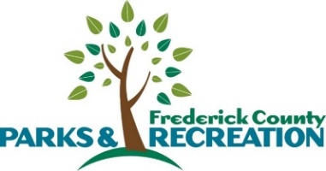
Frederick County Parks & Recreation
FY2026 Community Grant
Submission Affirmation

This form serves as a substitute if the President of an organization is not available to submit the online application/sign the application.

Frederick County Parks & Recreation Community Grant application requires the signature of the President of the HOA or organization(s). The signature provided by the President of the HOA or organization(s) affirms the accuracy of the information provided to the best of their knowledge, and the pledge of the President /organization to adhere to the established policies and procedures for the Community Grant Program. The signature also affirms that you hold the position of President. Finally, the President and organization also attest that the project, its location, new construction, and renovations adhere to all regulations outlined in the Frederick County Code.

Date: __________________ Signature: __________________________________
President of: ________________________________

Name: (type) ________________________________

