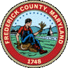
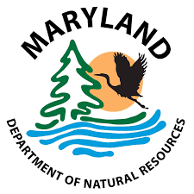

Frederick County

Local Program Open Space

Annual Timeline & Checklist Procedures

General Overview
Program Open Space (POS), in Frederick County is a state administered grant program for acquisition and development of park lands. Currently any POS funds allocated to Frederick County are split by 50% with the 12 municipalities. Dependent upon the Land Preservation Parks and Planning (LPPRP) goals will determine the POS percentage split between acquisition and development projects.
As of FY2024, Frederick County has met its land acquisition goal; therefore, the allocation split is 75% used for development and 25% used for acquisition projects.
This also means, the local match for development projects is 10% while POS funds will cover the remaining 90%.
There are no match requirements for acquisition projects.
Development projects can mean park rehab, building rehab, playgrounds, park amenities, etc.
~
Acquisition is a land purchase.

Above graphic for example purposes only


This document should be used only for a general overview of the annual allocation process between Frederick County and Frederick County Municipalities. Further details can be found by visiting the Maryland Department of Natural Resources website:
https://dnr.maryland.gov/land/Pages/ProgramOpenSpace/home.aspx

Annual Timeline & Check List

January - Governor’s Allocations are estimated in the annual state budget process. No action is required at this time.

February

Frederick County prepares and sends out memorandum notice to the municipalities detailing estimated
annual allocation (if available), updates to program processes and call for project submissions.
February Items Due
- Receive & Review Memorandum.
- Receive Access to Pre-Qualifying Questionnaire. Completion due date is May 1st.
March – April
During this time municipalities will meet to discuss and prioritize projects amongst various stakeholders.
Completion of the Pre-Qualifying Questionnaire is due by May 1st.
While considering potential projects, please note the following:
- FY2026 Process Update – The Project Information Form has been replaced with a NEW Pre-Qualifying Questionnaire
Responses in the Questionnaire should include the following when prompted:
  - Vendor quote(s) and or project proposal/cost estimates
  - Project schedule – (priority may be given to shovel ready projects)
  - Project site plan
  - Map with location marked
Once Frederick County receives questionnaire submission, further clarification may be necessary dependent on submission details, which may result in completing and resubmitting the questionnaire.
- When assessing your current POS projects, review the project status and determine if additional funds will be required to complete the project.
POS Local funding will be considerably less than in prior years. We encourage a thoughtful project selection process to ensure funds are allocated where they are most essential.
- If you are considering a project that was previously submitted but not funded, the project must be resubmitted. Please ensure that proper communication is relayed to the relevant municipal officials, as this information has only been sent to Municipal Project Coordinators.
When possible, combine multiple components of elements into one Project. For example, instead of submitting a project for parking lot paving, another for the tennis courts, then for the playground, combine these elements into one project for “_____ Park Improvements.” This will allow funds to be fully spent, and reduce the number of applications prepared, reviewed, approved and tracked by everyone. UPDATE: any remaining funds from new Municipal projects will be reverted to the municipal unencumbered balance for distribution during the next Frederick County Annual Program cycle.

May -.
May Items Due
- Pre-Qualifying Questionnaire submitted with Support Documentation are due May 1st.

Once all questionnaires are submitted and reviewed by County staff, the project totals are listed on the total allocation form. Once completed, the allocation form, pre-qualifying questionnaire and supporting documents are sent out to the municipalities for review. Any noted updates are made and a final version is sent back to the municipalities prior to the meeting.
The Municipality Secretary will then facilitate a meeting with municipality leadership and officials and County Staff to discuss projects and determine the funding outcome.
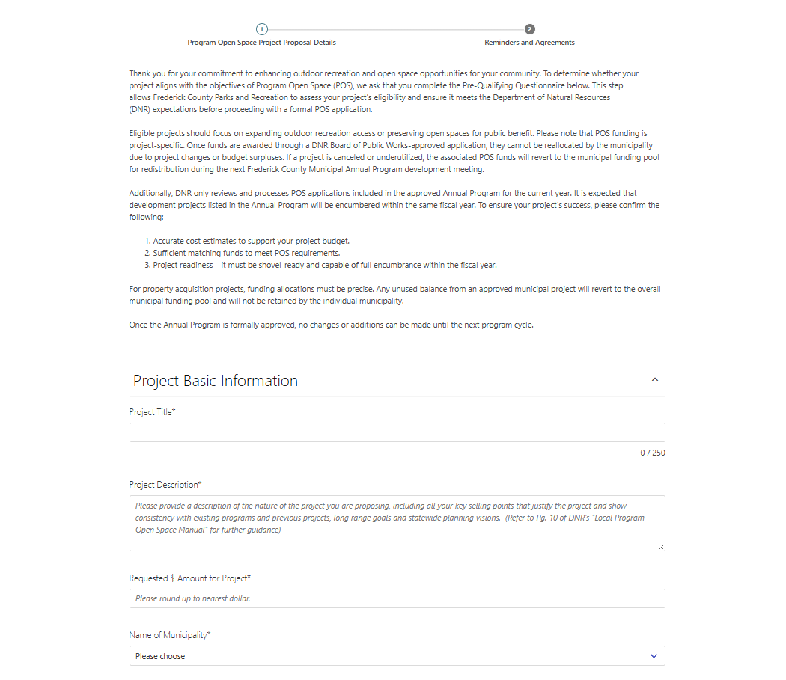
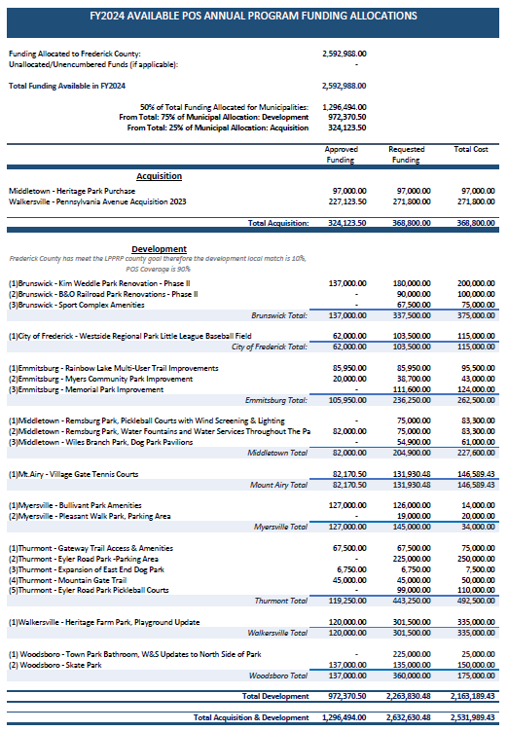
Pre-Qualifying provides the specifics of a project, while also providing guidance to fill out the DNR application. There should be 1 questionnaire submitted for each project.

The allocation form will list projects from all municipalities that have submitted projects.

For example purposes only
For example purposes only
June - Dependent upon the municipality meeting; the final project funding allocations will have been determined by June.
Note: Projects that have been funded through the allocation process will still need to go through the application process. The project cannot start until the Board of Public Works (BPW) has approved the application.
The County will now prepare the Annal Program. Previous versions of approved annual programs can be found on our website under the ‘About Program Open Space’ section.
Annual Program Definition:
A participating local governing body shall submit an Annual Program to DNR and MDP no later than the first day of July each year after obtaining approval of proposed projects by their local governing bodies. Upon review, the Annual Program shall become the basis for total allocations to each of the local governing bodies within the limits imposed by the formula developed for the apportionment of the annual appropriations for POS. The local governing body of any municipal corporation may submit an annual program through the local governing body of the county in which it is located. Any Annual Program may be revised by the local governing body. A revised program shall be substituted for the original program only after DNR and MDP review it, and DNR approves it. Guidelines and forms for preparation of Annual Programs are found in the chapter titled Annual Programs.

Municipalities cannot move forward with their application until the Annual Program has been submitted to DNR and approved by DNR.

July – The Annual Program is submitted for DNR approval.
The Annual Program must be approved by the DNR prior to any application submissions. After the Annual Program has been approved Frederick County will provide the Funding Authorization required for an application.
Applications should be submitted directly to the specified Department of Natural Resources (DNR) staff, and Board of Public Works (BPW), with a cc to POS@FrederickCountyMD.gov. All applications will be reviewed/approved by BPW and DNR. General turn around time from application submission to being placed on the BPW agenda can take up to 3 months or otherwise determined by DNR staff.

For additional information regarding application & reimbursement requirements please visit the DNR website:
https://dnr.maryland.gov/land/Pages/ProgramOpenSpace/home.aspx

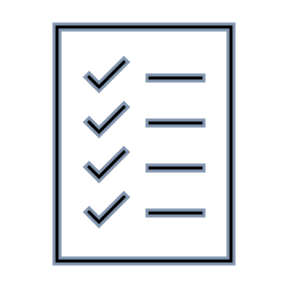
Application Check List
Acquisition Check List
Application
County/City Road Map with area(s) to be acquired marked in red.
Acquisition Line Map
2 independent Appraisals
Deed/Lease/Joint-Use-Real Property Sheet
Funding Authorization – Provided by Frederick County after Annual Program approval
Project Consistency Letter/Local Planning Letter
Descriptive Photos
Applicant may use photos from the appraisals to include in the application packet

Development Project Check List
Application
County/City Road Map with area(s) to be developed marked in red.
Project Site Plan/Map
Floor plans – if applicable
Deed/Lease/Joint-Use-Real Property Sheet
Funding Authorization – Provided by Frederick County after Annual Program approval
Project Consistency Letter/Local Planning Letter
Storm Water Management description and “Green” Building Technique/Material description – if applicable
Descriptive Photos

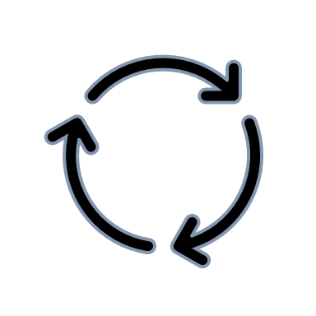
Review:

- Allocations are determined – funds are considered UNENCUMBERED.

- Annual Program (AP) is submitted & Approved.

- Applications are submitted & Approved after AP is approved.
Once applications are approved: Projects may start and the funds are then considered ENCUMBERED.
Note: POS Local unencumbered funds are subject to the State Finance and Procurement Article -- s.7-305 for Capital Expenditures and s.8-128 for General Obligation Debt -- where the authorized funds automatically terminate 7 years after the date of authorization.
- Once project has been completed a reimbursement request can be submitted.

